BRAC UNIVERSITY

Department of Computer Science and Engineering

CSE420: Compiler Design

Quiz 03, Fall 2015

Duration: 1.00 hours, Total Marks: 30

**Student Name:**

**Student ID:**

**Section:**

1. With the help of an example describe the “next-use” algorithm.[4]
2. Consider a hypothetical machine with four registers R1, R2, R3, R4 and six addressing modes with the following costs.

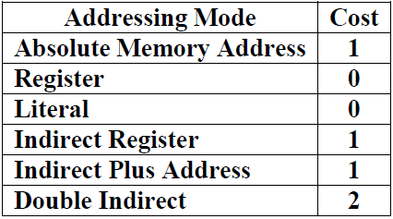

Now use an efficient algorithm to generate code for the target machine from the following block of 3-address codes:

t1 := a + b

t2 := t1 * c

t3 := t2 – t1

b := t3

Calculate the cost of generated code. [2+2]

1. Consider the code segment below: [3+3]

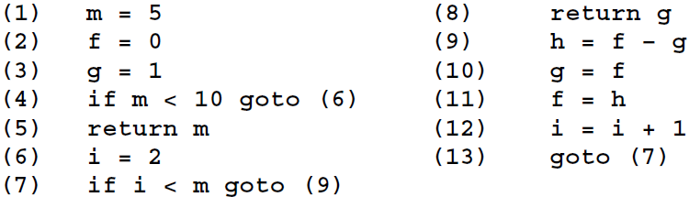

i. Construct a flow graph.

ii. Find the live variables at the end of each block.

1. Define “Call Graph” with appropriate example. [2]
2. Define Display registers with example. [2]
3. Draw the block diagram of activation record. [4]
4. Consider the following fragment of intermediate code:

y = w

z = 4

v = y * y

u = z + 2

r = w ** 2

t = r * v

s = u * t

Assume the only variable live at the exit is s. Show the result of applying constant propagation, algebraic simplification, common sub-expression elimination, constant folding, copy propagation and dead code elimination as much as possible to this code. You should explain the changes in each step. [6]

1. What is meant by dead code? Give examples.[2]